INTRODUCTION

Books have been with us since days of old and they served well in storing data and information of various things man have discovered and understood throughout the years. These books tend to be conglomerated in a repository building known as a library. People are usually free to roam within the halls of these kinds of building to search for various sources for them to read.

A ton of books get borrowed, used, and read in a library. a flood of books displaced from their dusty shelf homes. But how would they be returned to where they came from if a library’s repository is as big as a man’s home? The Dewey classification system. By the use of this management system, returning books and locating them is an ease.

We have around 700 students, more or less, in the institution which may or may not use the library for their leisure, studies, or rest. This number may potentially come to find resources for their studies along with the faculty staff and visitors coming by on our library.

This project is directly aimed at our local school library – the Batanes state College library. With their loss of their previous system’s functionality, they have returned to a more arbitrary manner of storing, fetching and collecting data through file cabinets, paper-based library cards, and manual file searching.

PROBLEM AND SOLUTION

There is a form of discipline librarians use to identify the location of books and studies stored within the numerous shelves found within a library called the “Dewey classification system”. It uses a very specific way of classifying books and arranging them within the rows of different shelves. The issue is this knowledge is rarely dwelled upon due to the growth of the development of the world wide web which may serve as an alternative to these physical repositories of knowledge. Albeit the existence of this marvel, libraries worldwide are still used due to being more eye friendly given it does not emit various radiation to users and can last much longer given it does not need batteries to operate. To answer the issue of having less people know of the manner of searching books effectively and efficiently, our predecessor students have devised a way to answer this dilemma by means of integrating a digital system which catalogs the books stored within our local library then displays its location for easier pinpointing. Apparently, over the years, their system somewhat ceased to function properly leaving the library to return to their old problem.

To aid in their dilemma, we took the opportunity to remake their system and make it our own making it modern and more focused on the users rather than the admins. The system catalogs the entire number of books in the library, indexes each of these books and displays it all within the bounds of the library computer’s screen. It can update statuses of each book whether it is available, borrowed or disposed of and locate which isle and shelf it is on. It will start by weaving through the indexes in the database to try and find a similar result for the given search and if there are any that matches the query, it will start to locate it within the library based on the given data in the database.

OBJECTIVE OF THE SYSTEM

**GENERAL OBJECTIVES**

* The system aims to improve the quality of life in the library
* The system aims to improve the management of the books in the library

**SPECIFIC OBJECTIVES**

* The system aims to guide library goers to find their desired books with ease and efficiency
* The system aims to guide library goers and librarians about the status of the book whether available, borrowed, or missing
* The system aims to unify the registration system with the catalog in order to ease the efforts of cluttering program changes

REQUIREMENT ANALYSIS

Project Name: Library Book Cataloging System (LBCS)

Project Developers: Noel Salazar, Christian Cantor, Phillipe Louis Garibay, Jean Marianne Elica

Requirement Analysis:

|  |  |
| --- | --- |
| **Functional Requirements** | **Non-Functional Requirements** |
| Book/Topic finder – Finds books within the database to pinpoint the location of the book in the library. | Library slides – If the system is not in use (after 2 minutes of staying idle), returns to a state that displays library facts and notices in a rotation of 15-60 seconds. It may also advertise books if necessary. |
| Digital Book Index – Catalogs all books and displays it as a list in the system. | Theme – The system’s theme will follow either a library-like or a book-like theme. |
| Book Status Index – Creates a status index for each book index in the database to determine if it is borrowed, disposed, or available. | Color palette – the color palette must include sky blue, aquamarine, or any blues within the range of the said colors, and yellow, mustard, or any yellows within the range of said colors. Other colors may be added if necessary |
| Add, Edit-Update, and Delete functions – Allows adding new indexes for new books, editing an index and updating it afterwards, and deleting of indexes in the database |  |
| Minor Details display – Shows book genre, type, book code, location, status, and a short description if there are any available. |  |

Approved by:

Marie Fe E. Pableo  
**_______________________________________________________________________** Board Secretary I / Acting Librarian

Date Signed: ________________

SOFTWARE FEATURE ANALYSIS

* Book finder – give instructions to users on finding/locating the book inside the library making it easier users.
* Digital book index – gives users a visual representation of the list of books consisting of information about each book.
* Book status index – this gives users a reminder of the books status if borrowed, disposed or available.
* Add, Edit, Update and delete functions – gives users of admin access level 2 and 3 to add, edit and update to books and delete.
* Minor details display – a small display showing the details of the book, from its genre, status, location, short description to make users choose the book that is right for them.
* Library slides – if the User-Interface is left idle or unused for 1min it will display an idle screen in which show library facts, and these slides change randomly from 15-60sec.
* Theme – the systems theme follows the color and vibe of the library.
* Color palette – in order to resemble the library’s theme, it needs the color of the following: sky blue, aquamarine, or any blue in that range and yellow, mustard, or any yellow within the range.

SOFTWARE DESIGN

1. SOFTWARE ARCHITECHTURAL DESIGN

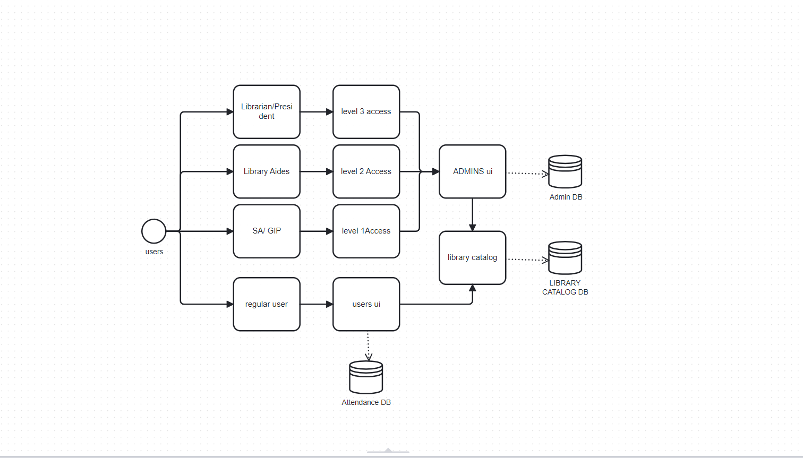

1. DATABASE DESIGN DOCUMENT (ER DIAGRAM)

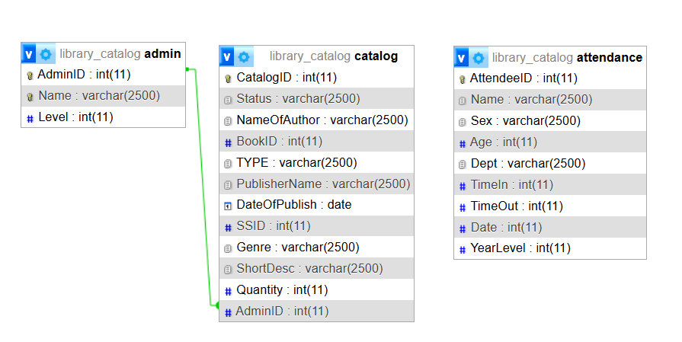

1. DATA FLOW DIAGRAM

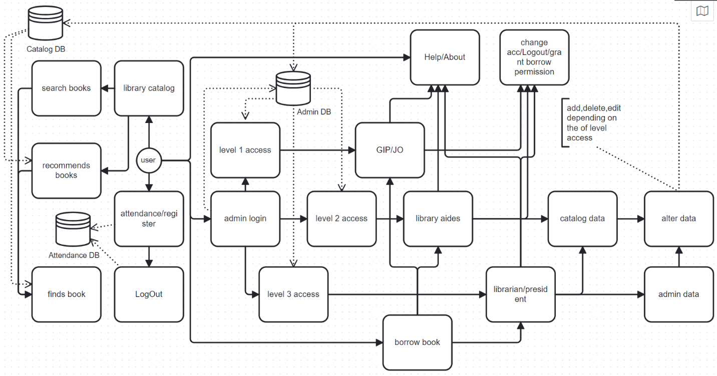

1. USE CASE DIAGRAM

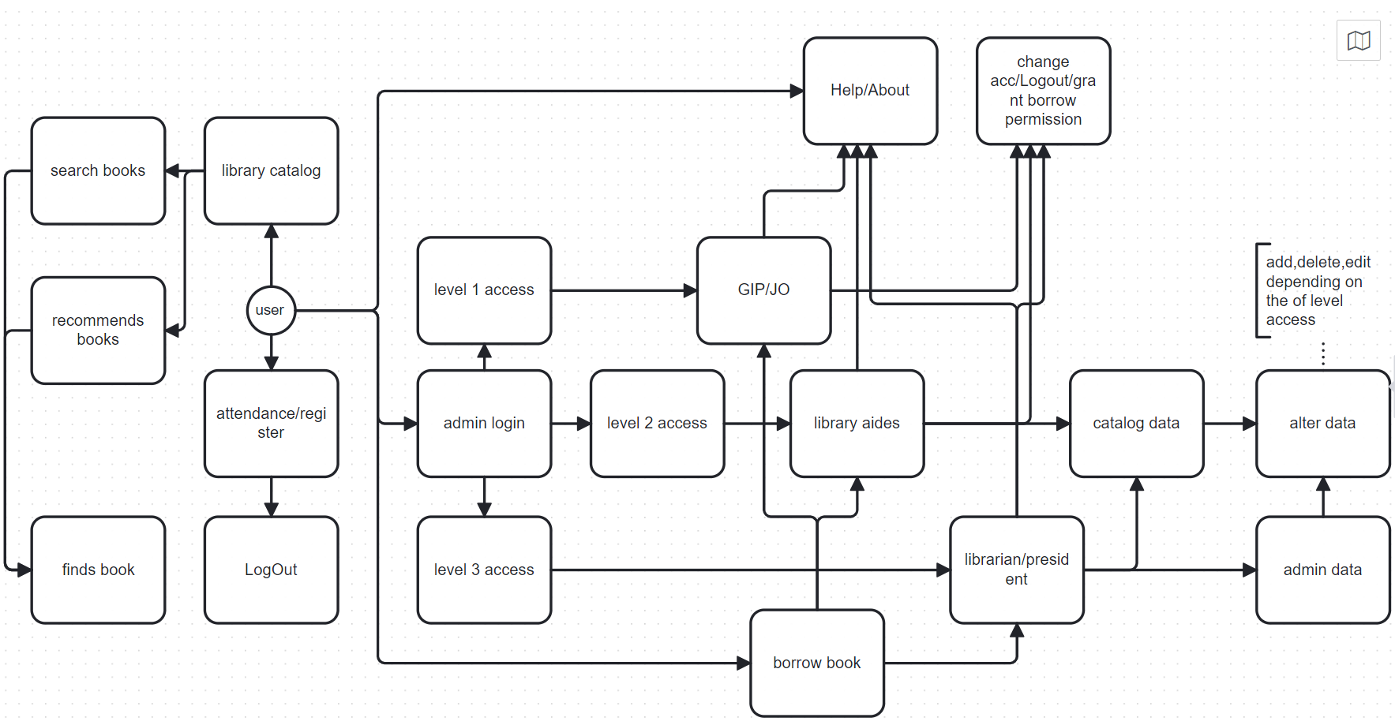

1. USER INTERFACE

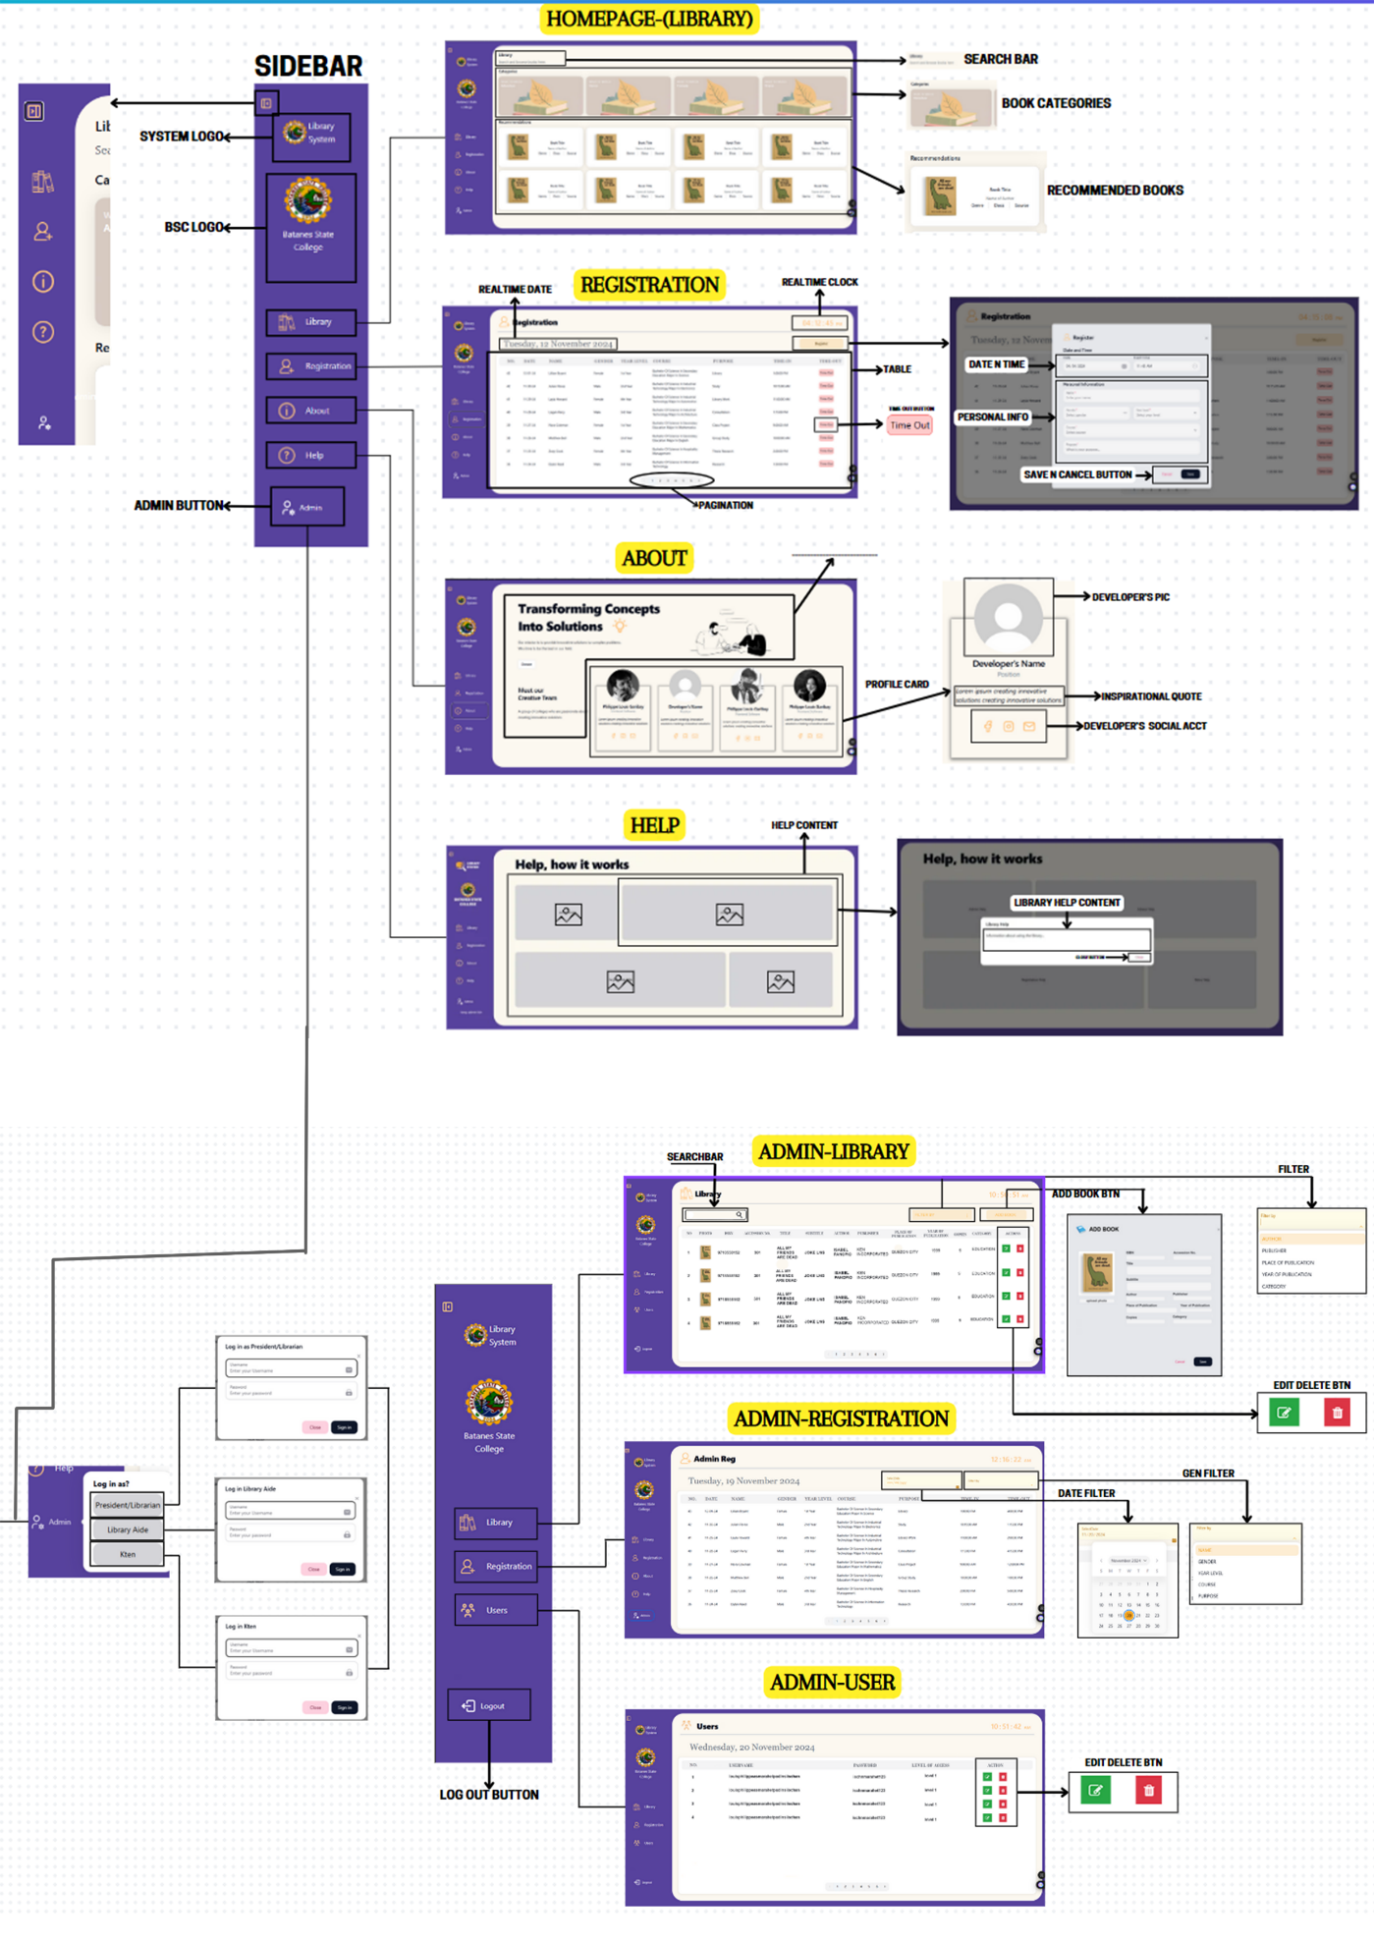

1. 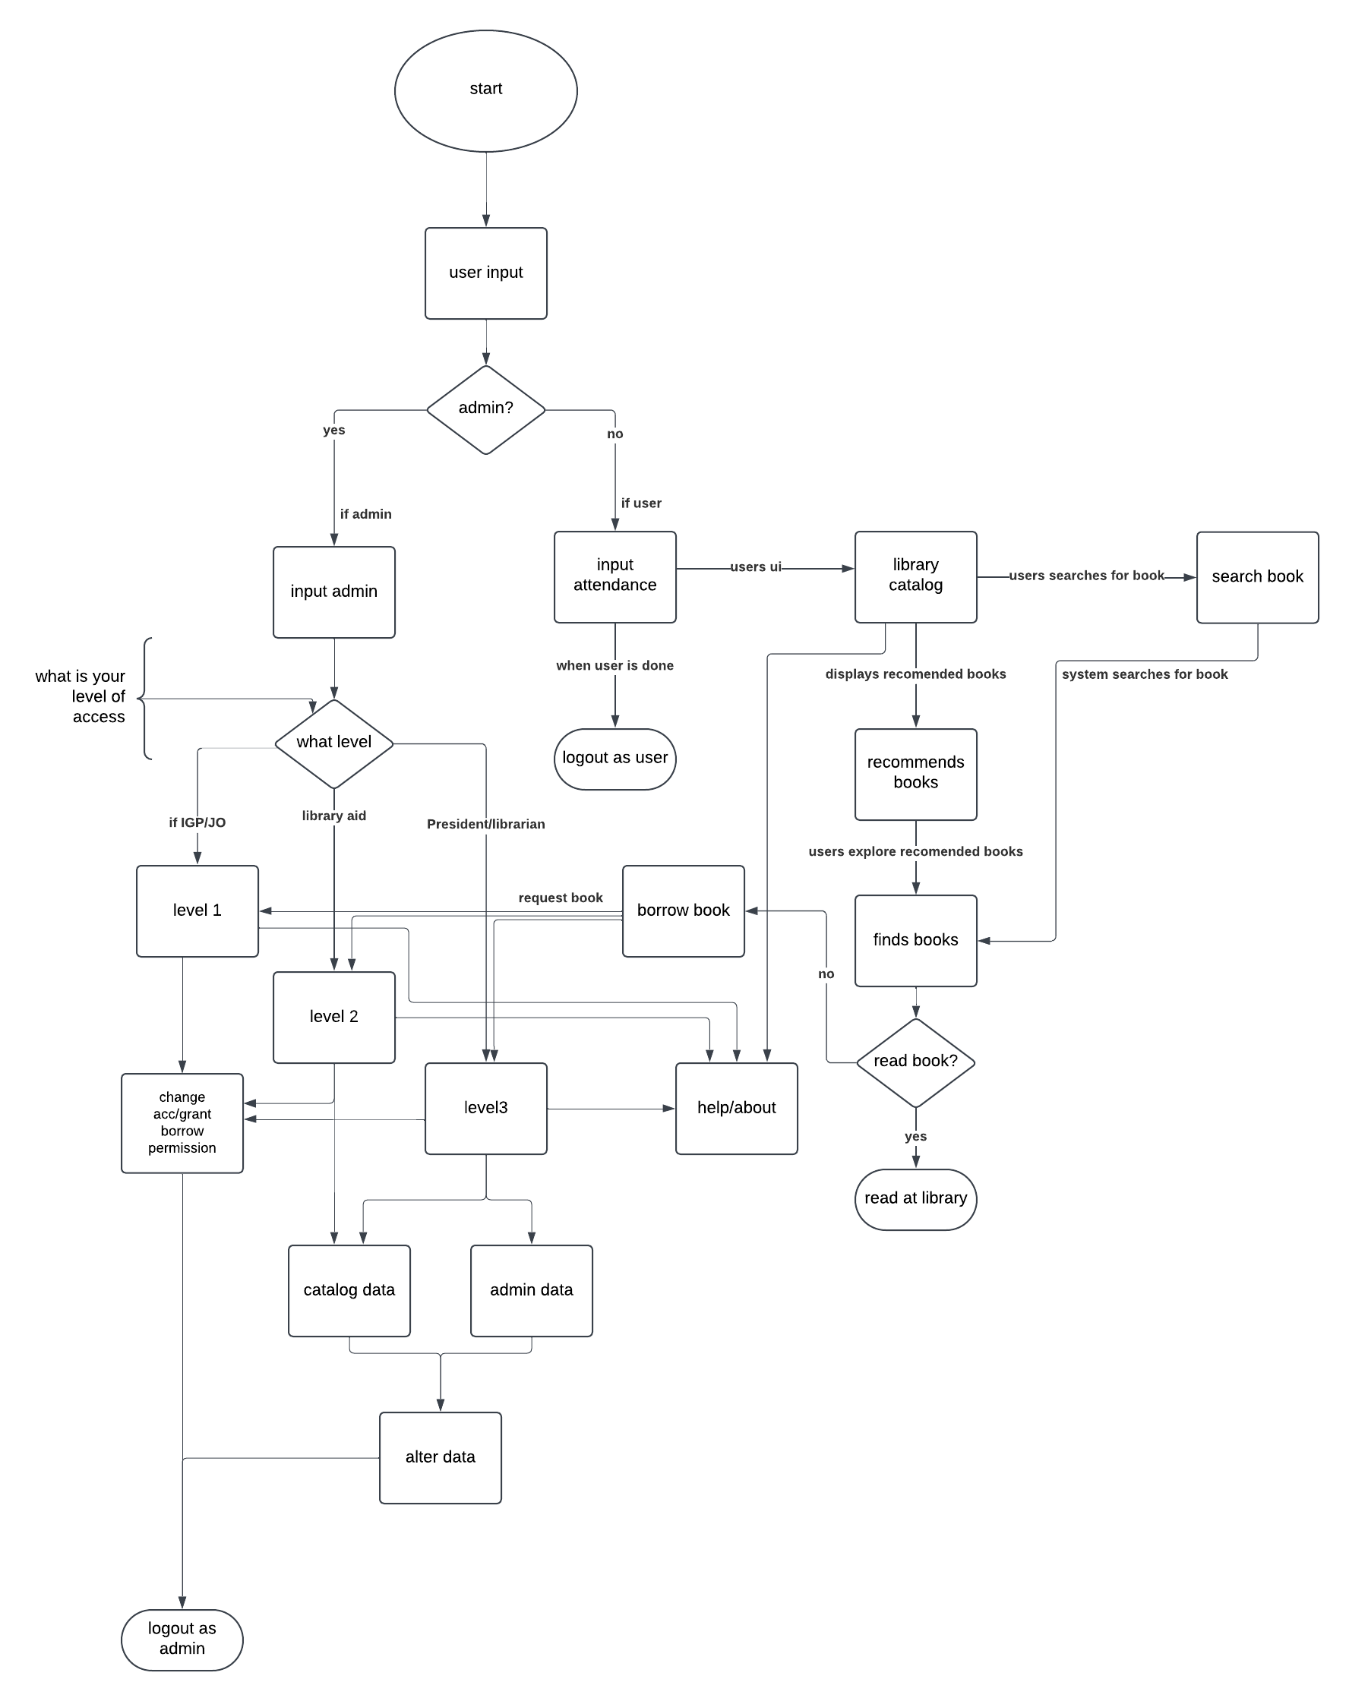PROGRAM FLOW DIAGRAM

TOOLS AND OTHER THIRD-PARTY COMPONENTS

Libraries used:

* Next UI
* Tabler Icons for icons

USER MANUAL

1. INSTALLATION MANUAL
   * Install xampp and run the application
   * Put the api file (back-end database material) into this directory windows/user/htdocs
   * Set up the html/page file somewhere in your computer (on your desktop or on a folder)
   * Run html file in a web browser and begin using it
2. OPERATIONAL MANUAL
   * User interface:
     + Registration: registers library goers for documentation purposes of the library
     + Library catalog: allows users to search for specific books available in the library and search for the books position inside the library while identifying if the book is available or borrowed.
     + About and help: shows the developer’s details and their handles for their social media accounts, and the manual on how to use the application (includes the wireframe deconstructed for an easier digestion of information and a few more details explaining the parts)
     + Admin log-in: allows users to log into an admin account depending on their choice; whether a level 1, 2, or 3 account and ask for a password for the said account
   * Admin interface:
     + Admin account management: allows changing, deleting, and adding of admin account if the current logged in account is a level 3 account (account for librarian and the school president)
     + Book catalog management: allows changing, deleting, and adding of books in the catalog if the current logged in account is a level 2 or level 3 account (account for librarian and the school president, and library aides)
     + Book status updating: allows updating a status of a book as borrowed, available or missing if logged in as a level 1, 2, or 3 account (any admin account)
     + Admin logout: logs out the admin to return to the user interface.
     + About and help: shows the developer’s details and their handles for their social media accounts, and the manual on how to use the application (includes the wireframe deconstructed for an easier digestion of information and a few more details explaining the parts)
   * Idle interface
     + Idle screen: if the system has not been used for 2 minutes, the idle screen appears and will show various library facts and books at a rotation of 15-60 seconds.
     + Interface return: upon an action is made (a key press, a mouse move or a mousedown), the system will return to the previous screen left before going idle.
3. UNIT FUNCTION DOCUMENTATIONS

DEVELOPER DETAILS

NOEL SALAZAR:

Project leader/ full stack developer

Handle:   
https://bsky.app/profile/adjournerharbringe.bsky.social

JEAN MARIANNE ELICA:

Front end developer/ designer

Handle:   
https://facebook.com/profile/jeanmarianneelica

PHILIPPE LOUIS GARIBAY:

Front end developer/ front end manager

Handle:   
https://facebook.com/profile/philippelouisgaribay

CHRISTIAN CANTOR:

Back-end developer/ back-end manager

Handle: `  
https://facebook.com/profile/christiancantor